**Dubai desert Safari**

**Summary :** Before you book Dubai desert safari , you must know well certain points , as their is points travel agency do not like tourists to know . Any way it is one from the most amazinf experience for any visit to Dubai .

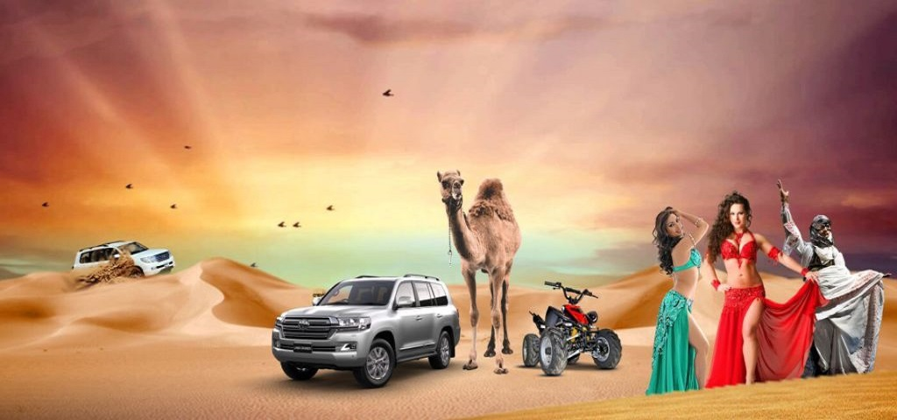

Dubai is considered one of the main cities of United Arab Emirates, consider now from the wish list for most travelers all over the world due to its famous landmark worldwide .

Before you visit Dubai , you must arrange your program well to not be confused upon arrival as Dubai is full of many sights to be visited .

One from important things to do in Dubai while visiting is to enjoy [**Dubai desert safari**](http://www.dubaibudgettours.com/desert-safari.php).

The magnificent landscape of this area and dunes attract many tourists to go their especially during winter as temperature become moderate.

**When to go ?**

The best time to enjoy [**Dubai desert safari**](http://www.dubaibudgettours.com/desert-safari.php) in the year from beginning of October to End of April as during summer it is hot , but if you can tolerate High temperatures you can do it .

**What to wear?**

Before you go to [**Dubai desert safari**](http://www.dubaibudgettours.com/desert-safari.php) **,**It is recommended to wear light clothes but to bring coat with you as sometimes at night it may be cold.

Eyeglasses and hats recommended bringing with you.

Light shoes or slippers is more comfortable to be wear during your trip.

As Dubai considered Arabian and Islamic country, so conservative clothes will be recommended, but that do not mean that you cannot wear short trousers or cut T Shirts.

**What is the most famous kinds for** [**Dubai desert safari**](http://www.dubaibudgettours.com/desert-safari.php) **?**

Morning Safari

Overnight [**Dubai desert safari**](http://www.dubaibudgettours.com/desert-safari.php) including 1 night in the camp

Afternoon desert Safari ( Recommended as it usually include show with dinner )

**What to Expect at Afternoon** [**Dubai desert safari**](http://www.dubaibudgettours.com/desert-safari.php)**?**

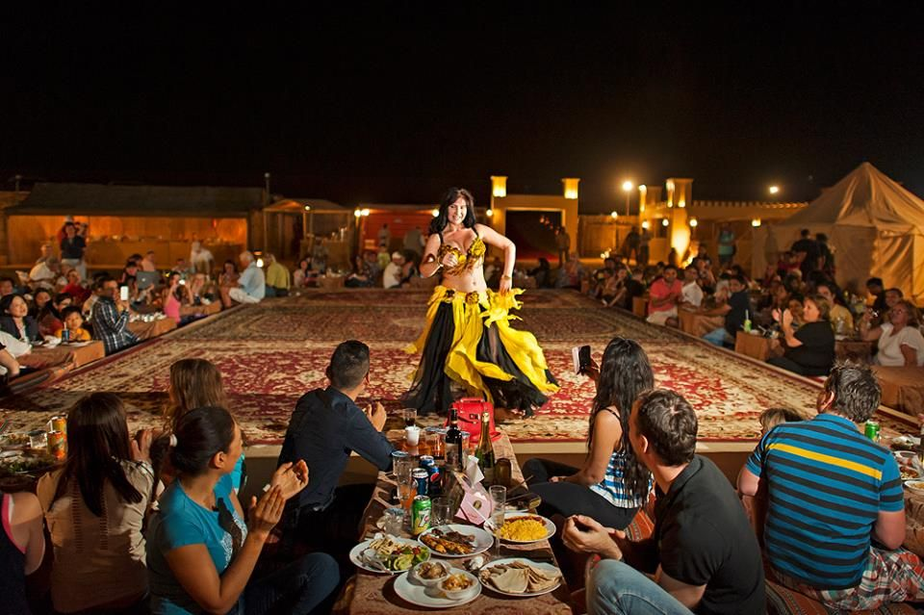

[**Dubai desert safari**](http://www.dubaibudgettours.com/desert-safari.php)trip to be operated with Air-conditioned 4 X 4 vehicles as there is long time of driving off road .

Deserts in Dubai characterized by its magnificent dunes.

Dune bashing considered from the most amazing things in [**Dubai desert safari**](http://www.dubaibudgettours.com/desert-safari.php) , so it is not recommended for pregnant women ,whom severing from backbones or heart problems ( you can ask your driver guide to skip dune bashing if you like )

Nice opportunity for honeymooners, couples and Romantic people as their will be Sunset watching from desert as you can take memorable and romantic views, there is short stop in certain spots in which you able to take photos

There will be chance for Camel riding as most companies offer short camel ride during [**Dubai desert safari**](http://www.dubaibudgettours.com/desert-safari.php)**,** after finishing the desert portion and while you are in the entrance of the camp their will be opportunity for camel ride at the gate of the camp , but do not expect more than 2 minutes ride as most probably it will be long queue waiting for this ride .

Falcon Show: The Arabian falcons has wide reputation worldwide, there is partition for Arabian falcon show in which you can have a chance to carry one of these falcons in your arm and take photos.

Henna painting: For ladies, there will be partition in which Arabian woman can do henna paints in your arms, you can choose from several designs

Smokers will have good opportunity to smoke Arabian Shisha, that characterized with several tastes as Apple , pitch , water melon , cherry and grape



Arabian Coffee and Arabian Dates: After the desert tour and upon arriving to the camp you will receive welcome drink inside the camp. You will enjoy the Arabian coffee and you can eat the Arabian dates with its amazing taste with the coffee, a taste you will never forget.

Be ready for the buffer dinner, either you are vegetarian or non-vegetarian; you will found wide verities that will be served at open buffet. Enjoy the oriental tastes and Barbeque and eat until you are full.

Be ready for the Night show ,At the middle of the Arabian deserts and in Oriental atmosphere , be ready for the show , the most Hi light for [**Dubai desert safari**](http://www.dubaibudgettours.com/desert-safari.php) is the night show in which you can see the Belly dancer , tanoura show and other shows also will be included .

**How to book?**

Many travel agencies offer online [**Dubai desert safari**](http://www.dubaibudgettours.com/desert-safari.php) tickets, rate varied mainly to the quality of camp and the verities in dinner and the night show.

Choose well the Safari that satisfy your needs and do not interfere with your timing especially if your time is limited .

In case you have stopover In Dubai , be sure that you will be dropped of on time as from the camp inside the desert till the airport it takes from 45 minutes to 1 hour .

It is recommended to have passport with you as may be authority require to check before going inside the desert.

For pregnant women and whom severing from any heart or back problems, please ask doctors before booking this trip.

Infants and children under 2 years will be on responsibility of their parents and while you are booking, ask your agency for baby seat.

**What Dubai travel agency hide during your booking for** [**Dubai desert safari**](http://www.dubaibudgettours.com/desert-safari.php) **?**

Be sure that transportation with 4x4 Air condition vehicles , that are adapted with 6 seats .

Be sure that dune bashing included during the desert portion.

No any Extra cost for the dinner buffet.

Ask for the program for the night show as it must include 2 or 3 shows, belly dancer show must be included.

Drop off in same your pick up location without any extra fees

Water and soft drinks included.

**What extra cost can be paid ?**

You can ask for private Safari trip (only vehicle private , while camp is mixed , vehicle can accommodate till 6 passengers )

Hummer vehicles safari offered with extra cost.

Sand boarding opportunity

Beach Buggy ride.

Remark : As Ramadan considered Holly month in Arabian and Islamic countries , Alcohols and belly dance show is not allowed during any booking in Ramadan for any [**Dubai desert safari**](http://www.dubaibudgettours.com/desert-safari.php) .

